Exploring Formulas with Excel

What happens if I place a 1 in the top cell and then do the following?
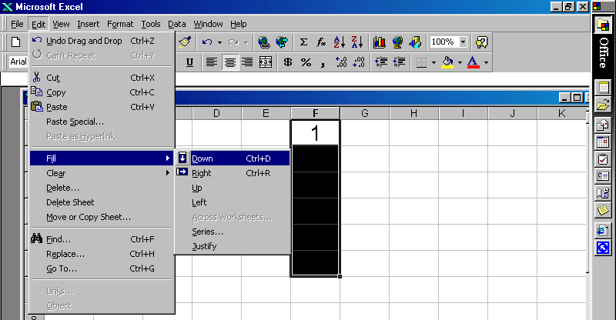

In order to produce a linear sequence you would select series and the following dialogue box would appear.

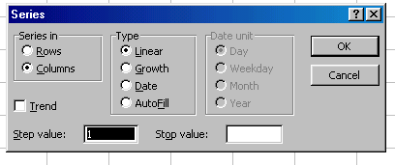
By changing the step value we can produce different sequences.

Produce the following sequences:

(Q1) | 1 | (Q2) | 3 | (Q3) | 4 | (Q4) | 6 | (Q5) | 2
 | 4 |  | 5 |  | 9 |  | 6.5 |  | -1
 | 7 |  | 7 |  | 14 |  | 7 |  | -4
 | 10 |  | 9 |  | 19 |  | 7.5 |  | -7
 | 13 |  | 11 |  | 24 |  | 8 |  | -10

If we wanted to know how many numbers we would need in the sequence in order to get to the number 58 we could fill series as before but this time enter a stop value of 58.

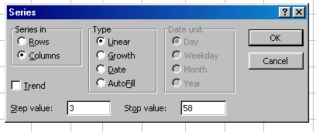
If the sequence begin in row 1 then you can use the numbers down the side to count the number in the sequence.
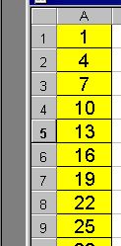

So for example 19 is the 7th number in this sequence.

For questions 1 to 4 above find out how many numbers you need to pass the number 100.

There is an alternative way of generating a sequence which appears more complicated but which is far more versatile. This involves inserting a formula and then copying it down the page.

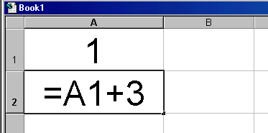
When you are entering a formula always press = first
If I now pressed enter this formula would work out the result to the number in cell A1 + 3 which is 4 and write it in the cell A2.

Now look what happens if I highlight the cell with the formula in (D2) and then drag down and click on fill down.

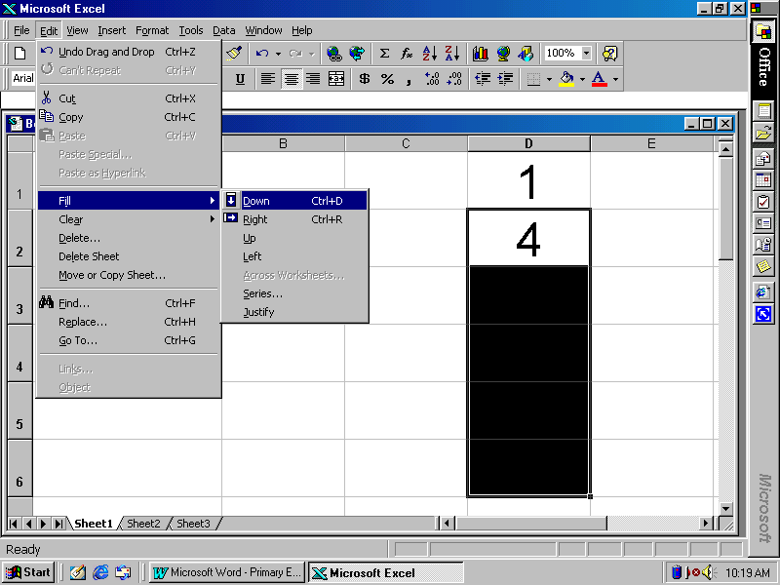
This is the result:

1 | These are the formulas | 1
4 |  | =D1 + 3
7 |  | =D2 + 3
10 |  | =D3 + 3
13 |  | =D4 + 3

You can see that as the spreadsheet automatically adjusts the formula so that you are adding 3 to the previous answer.

Change the number in cell D1 from a 1 to 5. What happens?

Use this method to generate sequences 1 to 5 listed earlier.

Now we have the basic tools lets combine these techniques.

We are now going to use the computer to produce the 3 times table in yet another way.

Put the numbers 1 to 10 in column A using the fill series command.
We are going to multiply each of these numbers by 3 to produce the 3 times table.
In cell B1 place the formula =A1*3 [note that * is used for multiply] so your screen should look like this:

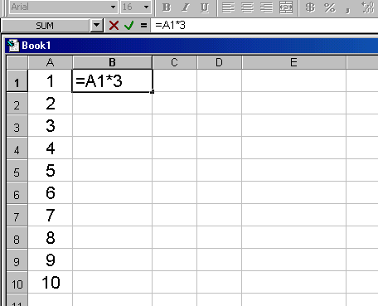

Press enter and the number 3 will appear. Now click on this cell and drag down to the 10th row and click on edit fill down.
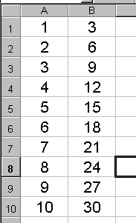
- In column C create the 4 times table
- In column D create the 6 times table
- In column E add the number in column C to the one
in column D. What does this give? (10 times table)
- In column F add the number in column A to the one
in column B. What does this give? (4 times table)

Use the skills you have learnt to produce a multiplication square up to 10 by 10.

Use the skills you have to create the following sequences:

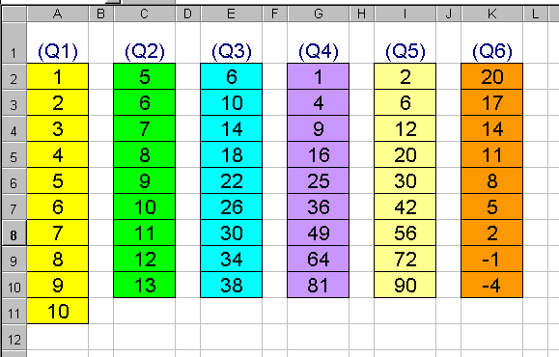
Extension work: Find out about the triangular numbers and about the Fibonacci sequence. Can you use a spreadsheet to produce these sequences? What is the 50th number in each of the sequences?

Triangular 1, 3, 6, 10, 15, 21, 28, 35, … 50th Triangular = 1275
Fibonacci 1, 1, 2, 3, 5, 8, 13, 21, 34, … 50th Fibonacci = 12586269025

